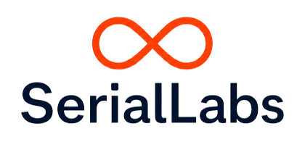
SERIALLABS / PATTERN-TO-PRODUCT
FROM RECURRING FRICTION TO AN EVIDENCE-BACKED DECISION
A Pattern-to-Product field guide for COO and CFO leaders, with a secondary lens for product and innovation teams
EXECUTIVE FIELD GUIDE
Recurring work is a signal to investigate. Productisation is a capital-allocation decision that must be earned by evidence.
VERSION 1.1 / 27 AUGUST 2026
Prepared by SerialLabs

01 / START WITH THE WORK

The executive decision
When should a recurring operational problem become a bounded system — and when should that system become a reusable capability or owned product?

Pattern-to-Product is a decision method for recurring exceptions, delayed decisions, fragmented evidence, manual coordination and local workarounds. It starts with one material process. It does not assume that repetition proves a market.

Four questions for an operating or financial owner
Question | What a defensible answer requires
Is the friction structurally recurring? | Repeated trigger, decision, action and outcome relations — not merely a common label.
Can a bounded intervention change the result? | Baseline, threshold, observation period, human authority and a stop rule agreed before results are seen.
What can travel? | A stable core separated from local data, integration, policy, language and operating roles.
Should we own a product? | Independent demand, safe rights, supportability, distribution and economics — not technical completion alone.

What the method can decide
- Stop when the pattern, result, rights or economics do not support further commitment.
- Investigate a named evidence gap with an owner, test and expiry date.
- Reuse internally when capability value exists without an independent market claim.
- Productise only when all gates are supported.

02 / WORKED ANATOMY

A pattern is more than a dashboard
Illustrative journey: Order Exception Control. A dashboard may display late orders; the operational pattern is the relationship between context, trigger, authority, evidence, decision, action and follow-up. The notation below prevents an interface or model from being mistaken for the pattern.
Element | Order Exception Control instantiation
C - Context | A distributor or manufacturer managing customer orders across inventory, warehouse and carrier systems
T - Trigger | A sequence of stock, fulfilment, cut-off, shipment or carrier signals raises the risk of a missed commitment
A - Actors | Supply-chain operations, warehouse, customer service, account owner and the systems that hold the evidence
I - Information | Order lines, stock, promised dates, warehouse events, carrier status, customer importance and prior interventions
D - Decision | Which order needs intervention now, why, and who is accountable?
X - Action | Assign ownership, expedite, replan, escalate or communicate with the customer within defined authority
O - Outcome | Earlier ownership and resolution, fewer avoidable misses, and a recorded explanation of what changed
G - Guardrails | Commercial thresholds, role permissions, escalation rules, evidence lineage and human approval for consequential actions

The product candidate is not ‘an exception dashboard’. It is a repeatable way to detect, decide, act and learn inside an accountable boundary.

03 / EVIDENCE LADDER AND CLAIM HIERARCHY

Evidence before commitment
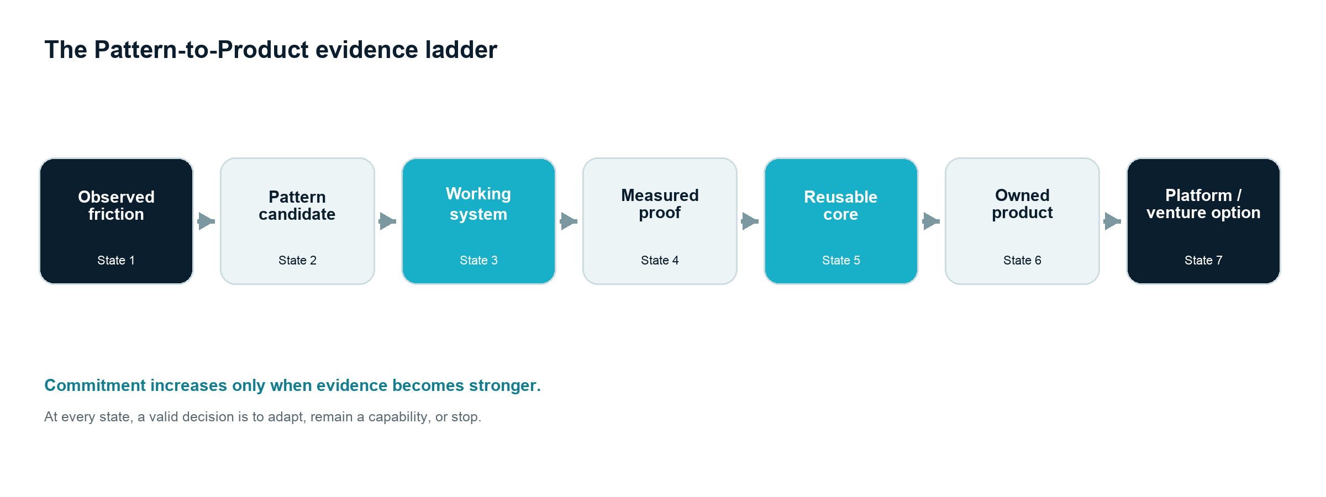
The Pattern-to-Product evidence ladder. Every transition requires a stronger kind of proof.
Claim being made | Minimum useful evidence | What it does not yet prove
A system can exist | Working implementation in a bounded environment | Safe operation or outcome value
The outcome moved | Predeclared measure, baseline, threshold and observation period | Causal attribution or transfer
A core can transfer | Second qualified context with bounded adaptation and no governance regression | Independent demand or viable economics
A product should be owned | Demand, distribution, rights, supportability and economic evidence | A platform or venture

A demonstration proves existence. It does not, by itself, prove value, transferability or a market.

04 / CAPITAL ALLOCATION

The seven productisation gates
Gate | Decision question | Minimum evidence
1 — Recurrent problem | Does the same material structure recur? | Independent cases, stable decision/outcome anatomy and understood counterexamples.
2 — Demonstrated value | Has a working intervention produced a meaningful outcome? | Baseline, observation period, threshold, outcome and claim boundary.
3 — Stable reusable core | Can a common core serve a second qualified context? | Transfer evidence, bounded adaptation, explicit interfaces and versioned evaluation.
4 — Repeated demand | Do independent buyers choose the same outcome? | Paid commitment, procurement movement, renewal, repeated use or credible willingness to pay.
5 — Supportable operating model | Can we implement and support it repeatedly without exceptional founder intervention on every sale? | Repeatable deployment, service levels, observability, incident response, change control and bounded support burden.
6 — Safe ownership and governance | Do we have the rights and controls to own and operate it? | Provenance, contractual rights, data boundary, risk controls, human authority and exit arrangements.
7 — Credible distribution and economics | Can it reach, convert and retain customers at a coherent cost? | Route to market, support model, product investment, horizon and credible cost ranges.

Two kinds of gate
Gate 6 is hard: unsafe rights or governance block productisation. Other evidence gaps may enter incubation only when the gap is named, testable, owned and time-bounded. Expired or failed gaps lead to reuse or stop — not indefinite waiting.
Core reuse and adaptation are independent measures. The first concerns the share of qualified functionality delivered by the core; the second concerns the share of delivery effort consumed at the edge.

05 / THE GATE REVIEW

Four defensible decisions
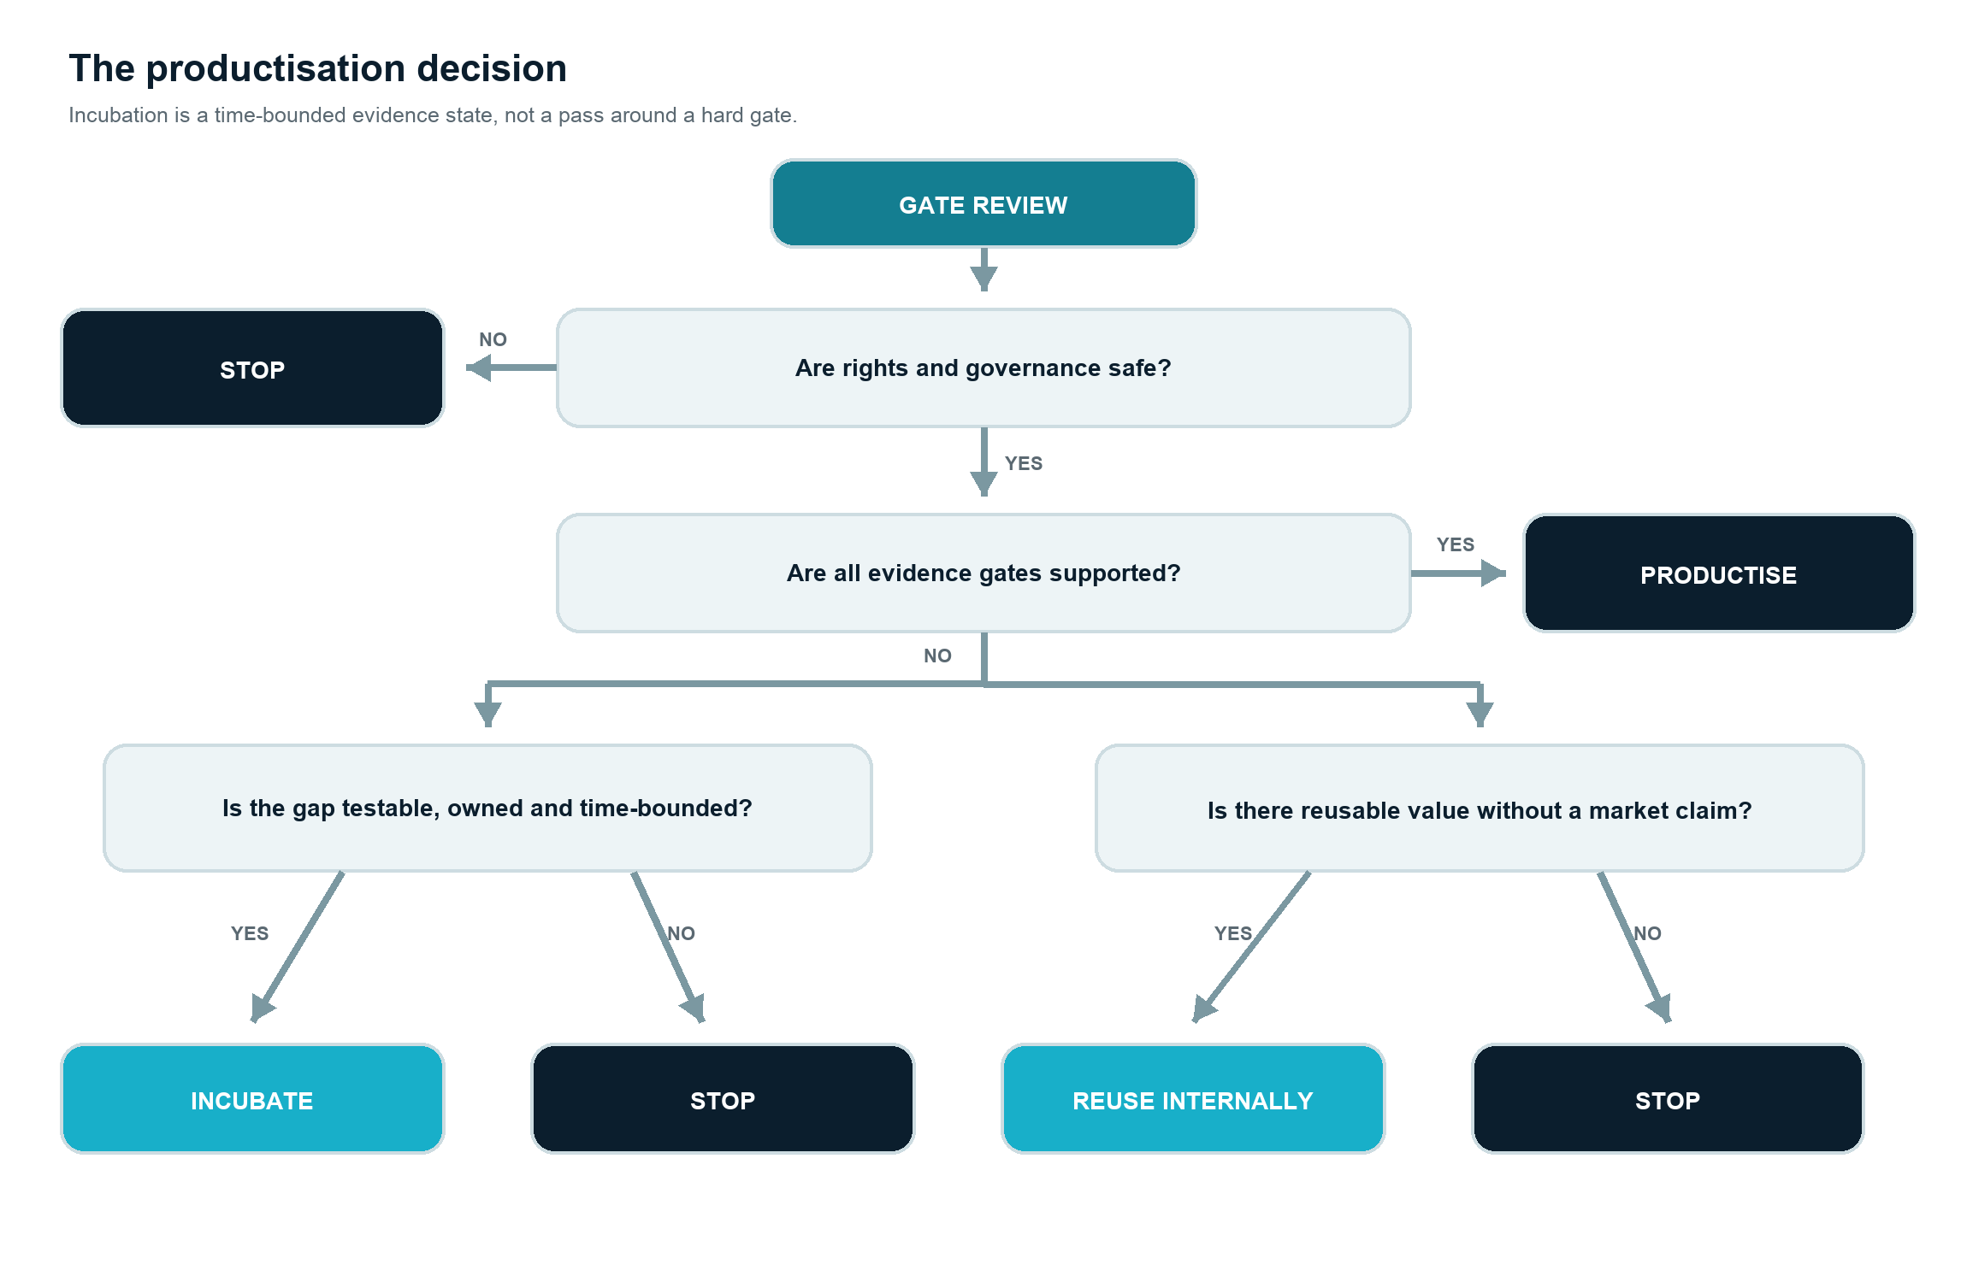
A gate review leads to Productise, Incubate, Reuse internally or Stop.
Decision | Meaning
Productise | All gates are supported; approve product ownership against a defined investment and review horizon.
Incubate | A named evidence gap has an accountable owner, predeclared test, budget and expiry date.
Reuse internally | The capability has legitimate repeat value, but the market claim is not supported.
Stop | The pattern, result, rights, governance, demand or economics do not justify further commitment.

06 / A BOUNDED FIRST COMMITMENT

AI Opportunity Sprint
The Sprint is a 2–3 week diagnostic around one recurring process and one bounded decision. It is designed to produce a better-evidenced next decision, not to pre-sell a product build.
Commitment | Defined boundary
Owner and access | Named operating or financial owner; people closest to the work; agreed representative examples or available data.
Deliverables | Current-state diagnosis, Pattern Candidate Record, initial pattern anatomy, evidence and rights gaps, scoped recommendation.
Decision | Stop, investigate a named gap, reuse a capability, or scope a separate paid Proof of Value.
Fixed fee agreed in advance | Before work begins, a signed scope states the fixed professional fee, included work, exclusions, expenses, taxes, payment terms and the boundary to any later Proof of Value.

Founding-partner sponsorship — exact terms
- Who pays: SerialLabs may fund all or part of the professional fee from its own business-development budget; the signed scope states the amount or percentage funded.
- Eligibility: one material process, an accountable operating or financial owner, timely access to representative evidence and participants, a credible decision, portfolio fit and capacity for method learning.
- Limits: sponsorship is capacity- and budget-limited and closes when the founding cohort is full. Unless expressly included, it excludes client internal time, third-party software or data, travel, procurement charges and extraordinary data preparation.
- No implied exchange: no obligation to provide publicity, transfer confidential data or IP, permit cross-client reuse, commission a Proof of Value, adopt a product or join a later productisation programme.

07 / BEFORE APPROVING THE NEXT COMMITMENT

Questions for the leadership team
COO lens | CFO lens
Where does the same exception repeatedly consume judgement and coordination? | What is the current cost of delay, rework, failure and manual control?
Who owns the decision and who may authorise action? | Which baseline, threshold and observation period would make an investment decision credible?
Which variations are legitimate operating edges rather than defects? | What fixed investment and deployment horizon are being approved — and against which non-product counterfactual?
What must never be automated or broadened without review? | Which support, assurance, integration and change costs remain after the prototype?

For product and innovation leaders
- Use operational deployments to discover real constraints, but prevent one early client from defining an incoherent core.
- Test independent demand separately from delivery success; when demand can be tested first at lower cost and risk, market-first may dominate.
- Treat every product claim as versioned evidence: system, population, period, metric, method, limitations and accountable approval.
The complete framework, evidence programme, gate records and references: https://www.seriallabs.com/pattern-to-product.
Start with the operating context, not a technology brief. A Sprint does not promise a product opportunity; it promises a better-evidenced next decision.

seriallabs.com / info@seriallabs.com

